28th March 2017

**Yokohama Rubber Launches SAE/EN Standards High-Pressure Hose “Versatran”**

Tokyo - The Yokohama Rubber Co., Ltd., announced the addition of “Versatran” to its existing product lines, new high pressure hose that meets the requirements of SAE and EN standard. In the global high pressure Hose market, SAE and EN standard products are widely used in Hydraulic products, offshore oil field, construction and industrial machinery for both OEM and MRO market. Yokohama Rubber currently supplies general-purpose wire braid hoses which match with those market’s demand. The launch of the Versatran hoses is part of the Company’s strategy to strengthen overseas sales of high-pressure hoses, especially for the challenging applications that require high-quality spiral hoses delivering exceptional performance and durability.

With the innovative material design, the Versatran hoses have superior flexibility, realizing smaller minimum bend radius compared with the most of the conventional spiral hoses available in the marketplace which follow the construction requirements of SAE and EN standard. The Versatran hoses are also certified by MSHA (Mine Safety and Health Administration) standard for flame resistance. The new hoses are imprinted with the Yokohama Rubber logo (Performance Y) in colour, ensuring their recognition as YOKOHAMA brand products. The Versatran hoses launched include five SAE 100R15 standard hose sizes with a maximum working pressure of 42MPa and two EN 4SH standard hose sizes, one with a maximum working pressure of 42MPa (Size 3/4) and the other 38MPa (Size 1”). The Company will steadily expand its offerings for both standards.

Yokohama Rubber high-pressure hoses available to overseas customers also include a wide range of ISO 18752 standard hose that has proven its performance with the Japanese construction machinery manufacturers.

*The name “Versatran” is an abbreviation of the words “Versatile” and “Transfer” which represent the unique features of the product.

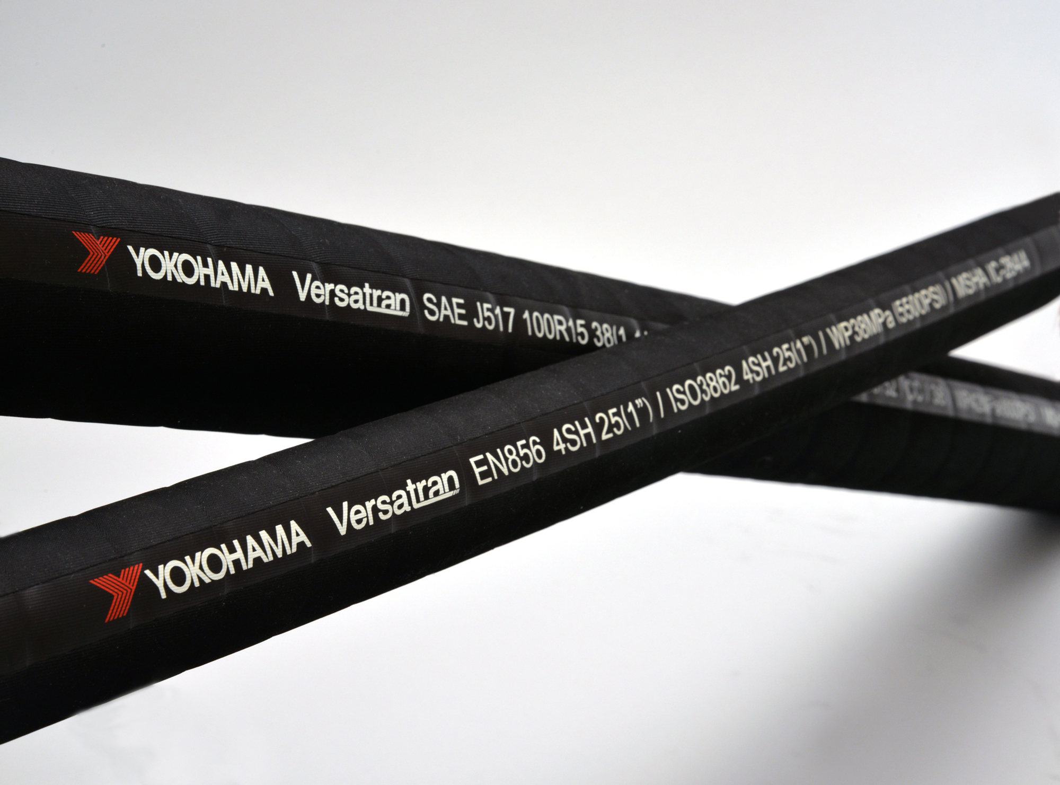

*Versatran hose*